Name: Md Nefaur Rahman Labib

ID: 17301147

CSE 460

LAB 5

Section: 12

Question 1: AND gate using CMOS

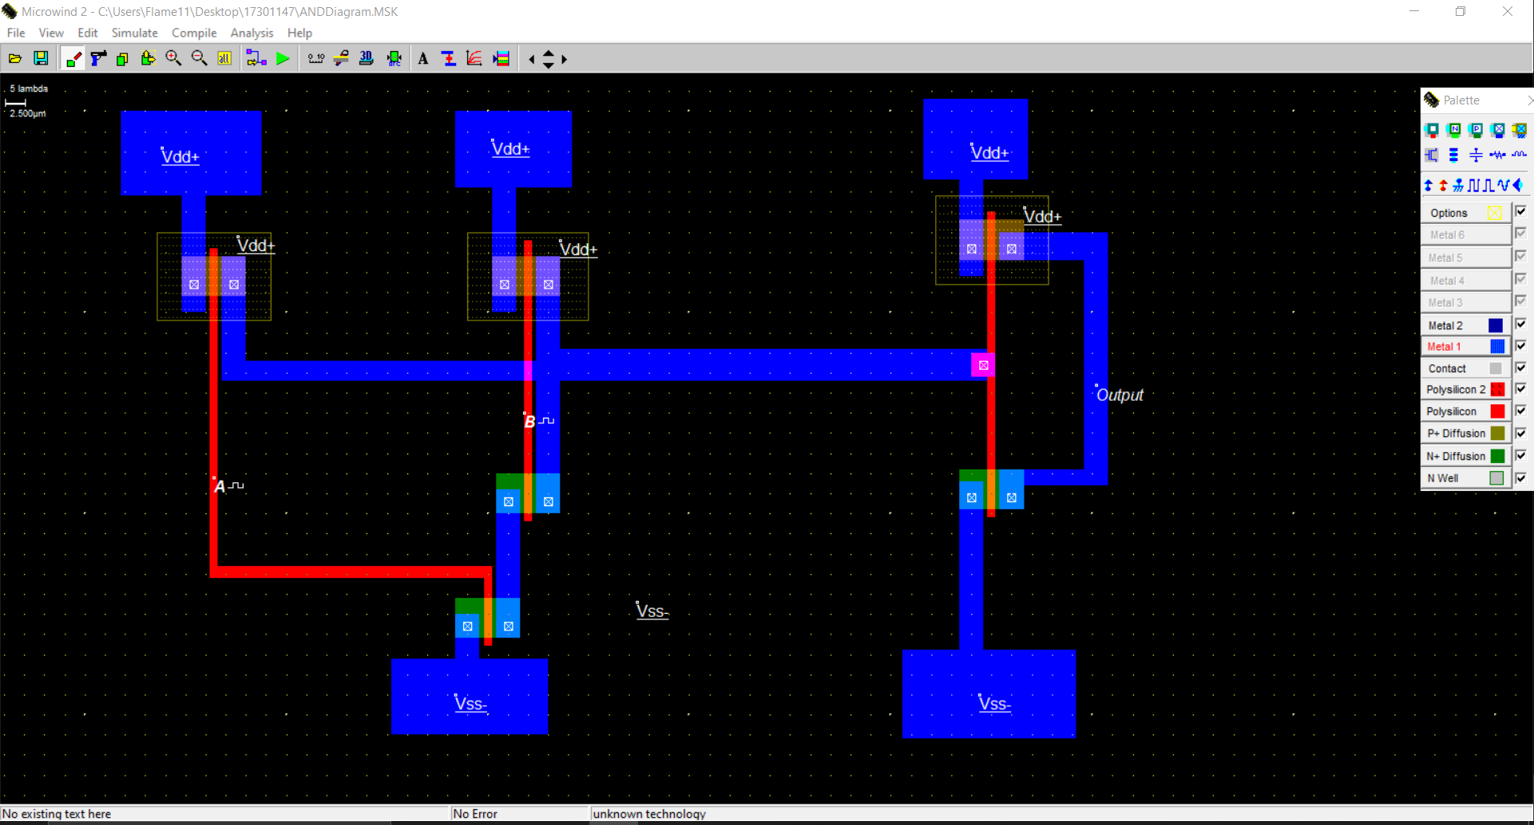

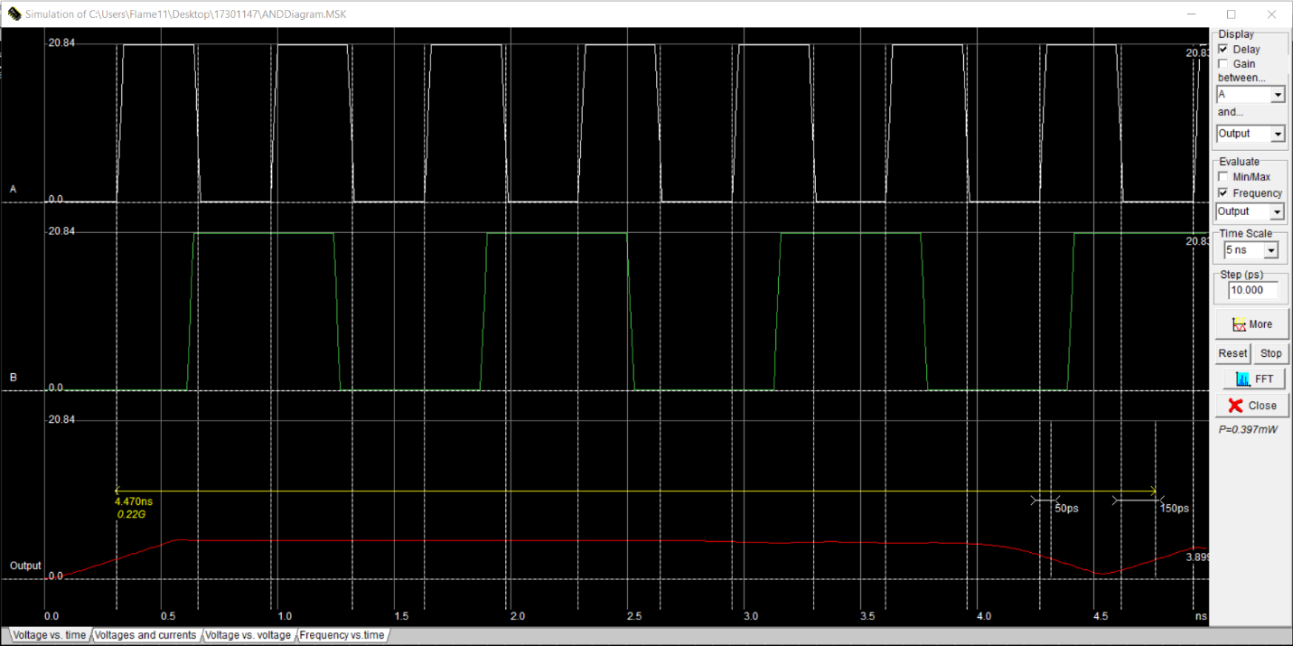

Question 2: 2 to 1 MUX using CMOS

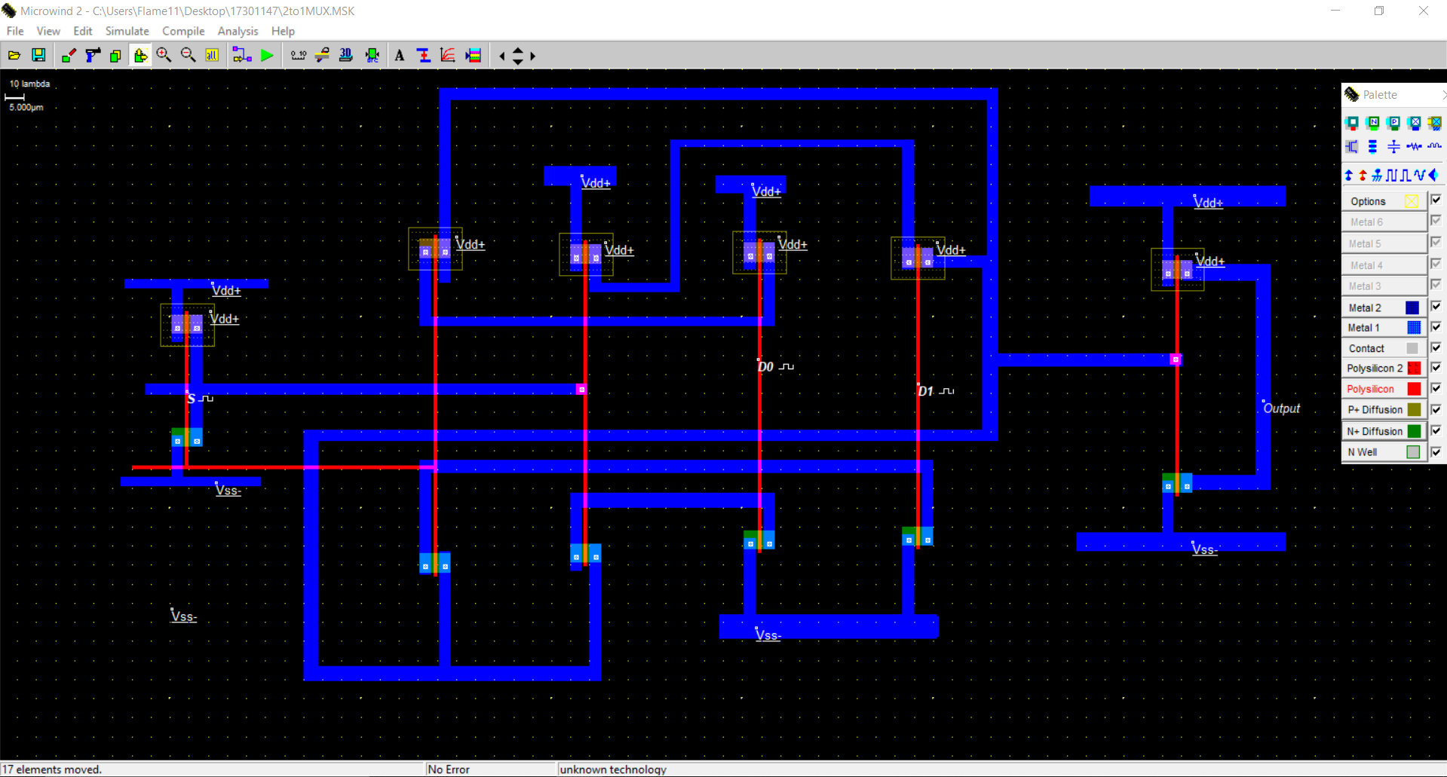

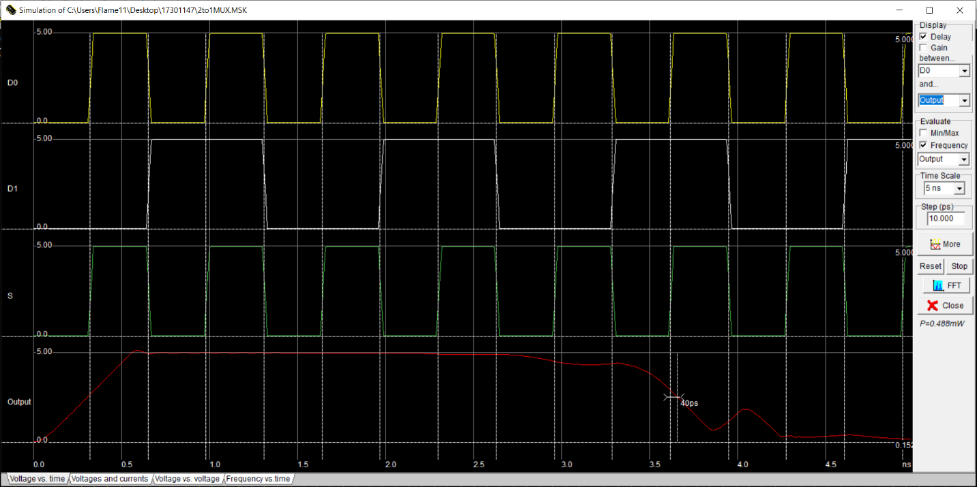

Question 3: f = (A+B) C

